**Introduction:**

On the Flintstones, a little bird sits inside the light and turns it on consistently before he hits the sack. In an advanced streetlight, a little circuit replaces the bird and turns the light on when the measure of light falls under a specific limit. Also, many street light controllers come with an astronomical clock for a particular location or a Global Positioning System (GPS) connection to give the best ON-OFF time and energy saving. As innovation progressed, lights were often controlled instead by a light sensor which detected when it was dark enough to need the lights switched on - even if the cause was a heavy storm cloud rather than nightfall.

**Objectives:**

§  Automation of street lamps

§  Lesser power consumption

§  More durability and flexibility

§  Lower expenses

§  Trouble-Free manufacturing

**Proposed Model:**

The automated streetlight controller has a Light dependent resistor, whose resistance changes proportionally to the amount of lighting, which automatically turns on or off the LED, saving power. The main principle of the circuit is to change in voltage drop across the LDR depending on the light source. When the LDR detects the presence of a light source it turns off the LED and when darkness is detected by the LDR, the light glows. By the help of this circuit, the LED works automatically and thus no manual switch is required, and we believe sufficient electricity can be saved from being wasted.

**Experimental Setup:**

* **Circuit Diagram:**

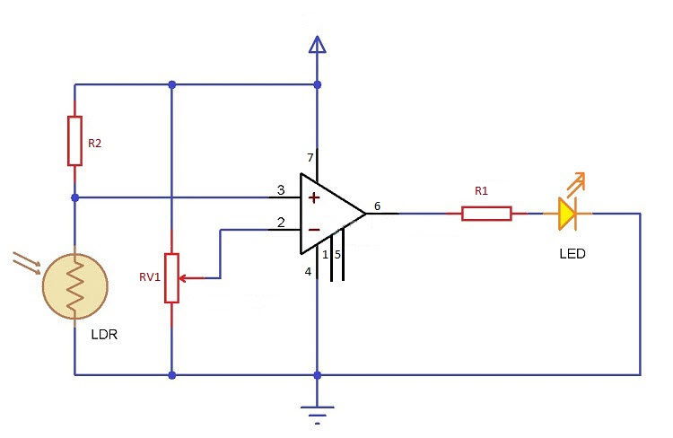

* **List Of Components:**

|  |  |  |
| --- | --- | --- |
| No. | Parts | Quantity |
| 1 | LDR | 1 |
| 2 | Resistor | 2 |
| 3 | LED | 1 |
| 4 | Power Supply | 1 |
| 5 | Operation amplifier | 1 |
| 6 | Potentiometer | 1 |
| 7 | Ground | 1 |

* **Specification Of The Components:**

* Light Dependent Resistor (LDR): LDR has a very high resistance normally but when they are exposed to light, their resistance decreases dramatically which makes LDR very useful in making circuits with light sensitive materials. The LDR has a high resistance when the light intensity is low which stops electricity from passing to the transistors' bases. As a result, the LED does not turn on.
* Resistors: Resistors help us to control the flow of current in the circuit. Resistance is the ability of a resistor to decrease current, and it is measured in ohms.
* LED: LED is used to get the output and detect the result of our circuit.
* Power Supply: Power supply is the device that helps us to provide electrical power to our circuit.
* Operation amplifier (op amp): A weak electric signal can be amplified using an operational amplifier, which is an integrated circuit. An operational amplifier has two input pins and one output pin and the voltage difference between the two input pins is amplified and returned as output. We used lm741 as an op amp.
* Potentiometer: A potentiometer is a resistor with variable and adjustable resistance that is controlled by a sliding or spinning contact. The potentiometer serves as a voltage divider to adjust resistance, decreasing or raising the voltage output by changing the resistance value. We used this to calibrate the intensity of light.
* Ground: Ground is used to make the circuit more safe as it attracts the excess charges from the circuit and removes them making the circuit safer. It eliminates the dangers of fire and electrocution

* Procedure

* First, insert 741 operational amplifiers in the middle.
* Then, take 1 resistor and LED light at the right side of the amplifier and take 1 resistor, a potentiometer and Torce LDR at the left side of the amplifier as the figure shown.
* Connect amplifier's 7 with power, 4 with ground, 6 with resistor of the right side, (+) with the potentiometer and (-) with the LDR.
* Connect the Right resistor with LED. Then, connect the LED with ground.
* Connect the upper side of LDR with power and down side with the Left resistor. Connect the left resistor with ground.
* Connect the potentiometer's one side with the power supply and other with the ground.

**Result:**

If we run the simulation then our D1(LED_BIBY) will be glowing as there is no light falling in the LDR1 (TORCH_LDR) earlier as we can expect this from our Automatic night light. To simulate the circuit, we have to move the light source closer to LDR1 which shows the day effect in the operator by pressing the plus pair. When the plus pair operator is very close to LDR1 (TORCH_LDR) that time LED’s (D1(LED_BIBY)) will be turned off. So, this simulation shows the effect of a day where at day LED will be turned off and at night it will be turned on. We can also change the value of potentiometer if anyone wants to turn on and turn off the LED which is the condition to calibrate it more accurately. To sum up, if anyone wants to turn on and turn off the D1(LED_BIBY) they can move the light source.

**Analysis:**

As we can analyze this we can say, the manually operated street lights are not switched off properly even when the sun light comes and also not switched on earlier before sunset. So, if we use this automatic system for street light controlling, we can reduce energy consumption.

**Advantages of using automatic street lights-**

• Low cost

• Automated operation

• Low power consumption

• Very flexible

• Easy to manufactured

**Disadvantages of using automatic street lights-**

In sunny and rainy days, on and off time differ notice which is one of the major disadvantages of using timer circuit or manual operation for switching the street light system

**Conclusion:** The Streetlight controller using the LDR1 based Light intensity & traffic density, now-a-days growing up countries will be more effective in case of cost, manpower and security as compared with today's running complicated and complex light controlling systems. Automatic Street Light Controlling System puts up a very friendly user approach that can increase the power. This project paper elaborates the design and construction of automatic street control system circuits. Circuit works properly to turn street lights ON or OFF. After designing the circuit which controls the light of the street as illustrated in the previous sections. LDR sensor and the photoelectric sensors are the two main conditions in working the circuit. If the two conditions have been satisfied the circuit will do the desired work according to the specific program. Each sensor controls the turning ON or OFF the lighting column. The street lights had been successfully controlled by a microcontroller. With commands from the controller the lights will be ON in the places of the movement when it's dark. Besides the drawback of the street light system using a timer controller has been overcome, where the system depends on a photoelectric sensor. Finally, this control circuit can be used in a highway which can be helpful at night to watch roads properly and drive carefully to avoid accidents. In the future, we can also save energy for future use and we can control the losses of the power. We can implement this project for the home lamp or night lamp of the room. This is also used for the signals.